Fifth Sunday of Easter
St. George’s Day
Holy Eucharist Rite II
April 28, 2024 – 10:30 AM
The Rev. Dr. Matt Boulter Julie Park, Music Minister
We’re glad you are here! If you are new to St. George’s, please complete the Welcome Card on the back of the pew in front of you and place it in the offering basket as it comes by during the offertory. Please join us after the service for conversation and refreshments at Kleberg Hall. At St. George’s we love all of God’s children! For crawlers through four’s we invite you to make use of our nursery (please find a F.A.Q. card near the entrances or ask an usher). Kids five years old through fifth grade are invited to KidsWord! Simply follow the banner in the opening procession of the service. KidsWord will rejoin us in the Nave during the passing of the peace.
WORSHIP BOOKS – The following is a key to the books used during the worship service, with the acronyms as used in this order of worship
H – 1982 Hymnal G – Gather BCP – Book of Common Prayer

Prelude No. 7 Andante – Aloys Claussmann Julie Park
THE WORD OF GOD
Opening Hymn Good Christians all, rejoice and sing! H 205
Celebrant Alleluia. Christ is risen.
People The Lord is risen indeed. Alleluia.

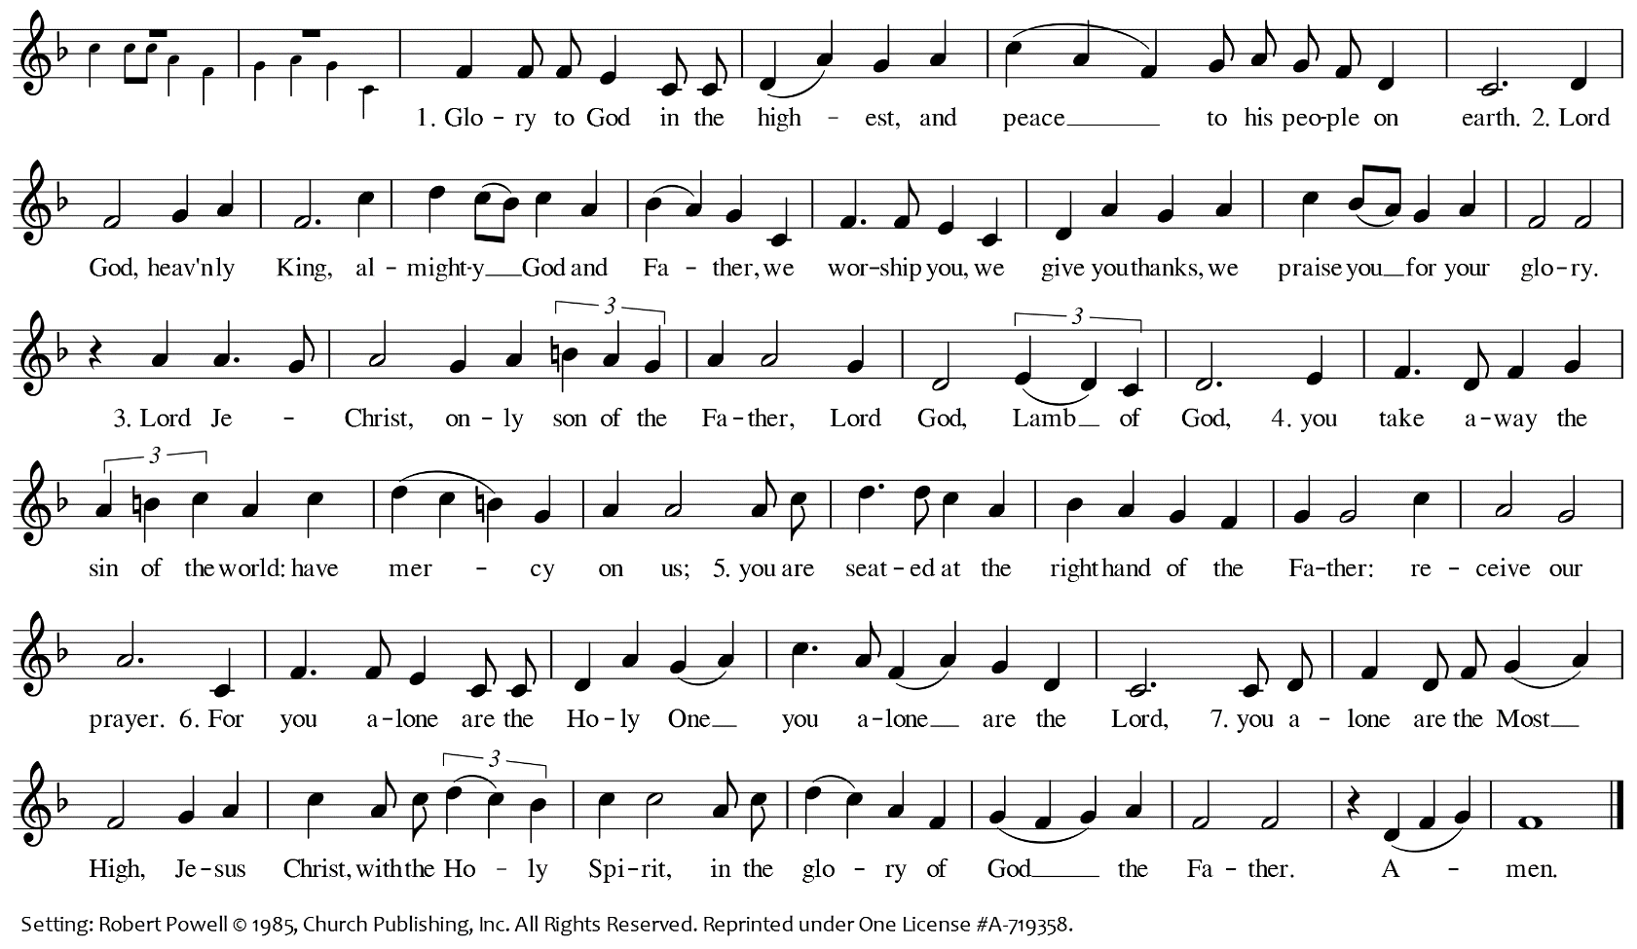
Gloria in Excelsis H S280

Celebrant The Lord be with you.
People And also with you.
Celebrant Let us pray.
Prayer of St. George
Celebrant Faithful servant of God and invincible martyr, Saint George; favored by God with the gift of faith, and inflamed with an ardent love of Christ, you did fight valiantly against the dragon of pride, falsehood, and deceit. Neither pain nor torture, sword nor death could part you from the love of Christ. Give us your spirit of courage and love, so that we may serve God and promote the wellbeing and health of our children, our neighbors, and our communities. Amen
The Collect of the Day BCP 235
Celebrant Almighty God, whom truly to know is everlasting life: Grant us so perfectly to know your Son Jesus Christ to be the way, the truth, and the life, that we may steadfastly follow his steps in the way that leads to eternal life; through Jesus Christ your Son our Lord, who lives and reigns with you, in the unity of the Holy Spirit, one God, for ever and ever. Amen.
Please be seated for the readings.
First Reading Acts 8:26-40

An angel of the Lord said to Philip, “Get up and go toward the south to the road that goes down from Jerusalem to Gaza.” (This is a wilderness road.) So he got up and went. Now there was an Ethiopian eunuch, a court official of the Candace, queen of the Ethiopians, in charge of her entire treasury. He had come to Jerusalem to worship and was returning home; seated in his chariot, he was reading the prophet Isaiah. Then the Spirit said to Philip, “Go over to this chariot and join it.” So Philip ran up to it and heard him reading the prophet Isaiah. He asked, “Do you understand what you are reading?” He replied, “How can I, unless someone guides me?” And he invited Philip to get in and sit beside him. Now the passage of the scripture that he was reading was this:
“Like a sheep he was led to the slaughter,
and like a lamb silent before its shearer,
so he does not open his mouth.
In his humiliation justice was denied him.
Who can describe his generation?
For his life is taken away from the earth.”
The eunuch asked Philip, “About whom, may I ask you, does the prophet say this, about himself or about someone else?” Then Philip began to speak, and starting with this scripture, he proclaimed to him the good news about Jesus. As they were going along the road, they came to some water; and the eunuch said, “Look, here is water! What is to prevent me from being baptized?” He commanded the chariot to stop, and both of them, Philip and the eunuch, went down into the water, and Philip baptized him. When they came up out of the water, the Spirit of the Lord snatched Philip away; the eunuch saw him no more, and went on his way rejoicing. But Philip found himself at Azotus, and as he was passing through the region, he proclaimed the good news to all the towns until he came to Caesarea.
Reader The Word of the Lord.
People Thanks be to God.

Psalm 22:24-30
Please read responsively in unison.
24 My praise is of him in the great assembly; *
I will perform my vows in the presence of those who worship him.
25 The poor shall eat and be satisfied,
and those who seek the LORD shall praise him: *
"May your heart live for ever!"
26 All the ends of the earth shall remember and turn to the LORD, *
and all the families of the nations shall bow before him.
27 For kingship belongs to the LORD; *
he rules over the nations.
28 To him alone all who sleep in the earth bow down in worship; *
all who go down to the dust fall before him.
29 My soul shall live for him;
my descendants shall serve him; *
they shall be known as the LORD's for ever.
30 They shall come and make known to a people yet unborn *
the saving deeds that he has done.
Second Reading 1 John 4:7-21
Beloved, let us love one another, because love is from God; everyone who loves is born of God and knows God. Whoever does not love does not know God, for God is love. God's love was revealed among us in this way: God sent his only Son into the world so that we might live through him. In this is love, not that we loved God but that he loved us and sent his Son to be the atoning sacrifice for our sins. Beloved, since God loved us so much, we also ought to love one another. No one has ever seen God; if we love one another, God lives in us, and his love is perfected in us.
By this we know that we abide in him and he in us, because he has given us of his Spirit. And we have seen and do testify that the Father has sent his Son as the Savior of the world. God abides in those who confess that Jesus is the Son of God, and they abide in God. So we have known and believe the love that God has for us.
God is love, and those who abide in love abide in God, and God abides in them. Love has been perfected among us in this: that we may have boldness on the day of judgment, because as he is, so are we in this world. There is no fear in love, but perfect love casts out fear; for fear has to do with punishment, and whoever fears has not reached perfection in love. We love because he first loved us. Those who say, "I love God," and hate their brothers or sisters, are liars; for those who do not love a brother or sister whom they have seen, cannot love God whom they have not seen. The commandment we have from him is this: those who love God must love their brothers and sisters also.
Reader The Word of the Lord.
People Thanks be to God.
Sequence Hymn I Am the Vine G 479
The Holy Gospel John 15:1-8
Celebrant The Holy Gospel of our Lord Jesus Christ according to John.
People Glory to you, Lord Christ.
Jesus said to his disciples,” I am the true vine, and my Father is the vine grower. He removes every branch in me that bears no fruit. Every branch that bears fruit he prunes to make it bear more fruit. You have already been cleansed by the word that I have spoken to you. Abide in me as I abide in you. Just as the branch cannot bear fruit by itself unless it abides in the vine, neither can you unless you abide in me. I am the vine, you are the branches. Those who abide in me and I in them bear much fruit, because apart from me you can do nothing. Whoever does not abide in me is thrown away like a branch and withers; such branches are gathered, thrown into the fire, and burned. If you abide in me, and my words abide in you, ask for whatever you wish, and it will be done for you. My Father is glorified by this, that you bear much fruit and become my disciples.”
Celebrant The Gospel of the Lord.
People Praise to you, Lord Christ.

The Sermon The Rev. Dr. Matt Boulter
The Nicene Creed BCP 358
Prayers of the People, Form III BCP 383-385
The Peace
Celebrant The peace of the Lord be always with you.
People And also with you.
The Ministers and People greet one another in the name of Christ.
Announcements
THE HOLY COMMUNION
Offertory Sentence
Offertory Anthem Go With Rejoicing – Gene Grier & Lowell Everson The Choir
Thank you for your generosity. You may place checks or cash in the offering basket. Offerings may also be made online at www.sgchurch.org (click “Give and then Donate”). As the offerings are brought forward, please stand, as able.
Presentation of the Gifts The Doxology 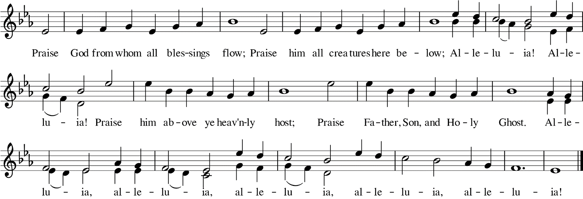
THE GREAT THANKSGIVING
Eucharistic Prayer B BCP 367
Celebrant The Lord be with you.
People And also with you.
Celebrant Lift up your hearts.
People We lift them up to the Lord.
Celebrant Let us give thanks to the lord our God.
People It is right to give him thanks and praise.
Celebrant It is right, and a good and joyful thing, always and everywhere to give thanks to you, Father Almighty, Creator of heaven and earth…. Therefore, we praise you, joining our voices with Angels and Archangels and with all the company of heaven, who for ever sing this hymn to proclaim the glory of your Name:
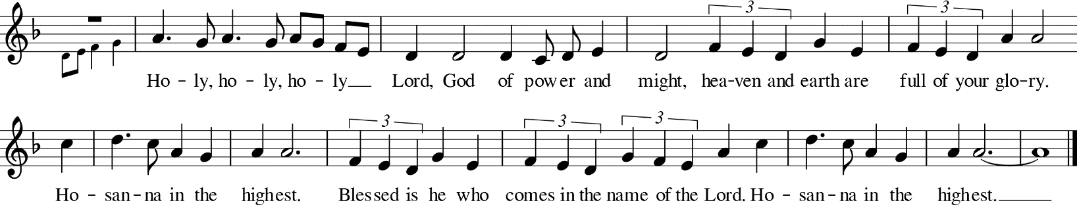
Sanctus H S 129

Celebrant We give thanks to you, O God, for the goodness and love which you have made known to us in creation; in the calling of Israel to be your people; in you Word spoken through the prophets; and above all in the Word made flesh, Jesus, your Son. For in these last days you sent him to be incarnate from the Virgin Mary, to be the Savior and Redeemer of the world. In him, you have delivered us from evil, and made us worthy to stand before you. In him, you have brought us out of error into truth, out of sin into righteousness, out of death into life.
On the night he was handed over to suffering and death, our Lord Jesus Christ took bread; and when he had given thanks to you, he broke it, and gave it to his disciples, and said, “Take, eat: This is my Body, which is given for you. Do this for the remembrance of me.” After supper he took the cup of wine; and when he had given thanks, he gave it to them, and said, “Drink this, all of you: This is my Blood of the new Covenant, which is shed for you and for many for the forgiveness of sins. Whenever you drink it, do this for the remembrance of me. Therefore we proclaim the mystery of faith.
People We remember his death,
We proclaim his resurrection,
We await his coming in glory;
Celebrant And we offer our sacrifice of praise and thanksgiving to you, O Lord of all; presenting to you, from
your creation, this bread and this wine.
We pray you, gracious God, to send your Holy Spirit upon these gifts that they may be the Sacrament of the Body of Christ and his Blood of the new Covenant. Unite us to your Son in his sacrifice, that we may be acceptable through him, being sanctified by the Holy Spirit. In the fullness of time, put all things in subjection under your Christ, and bring us to that heavenly country where, with all your saints, we may enter the everlasting heritage of your sons and daughters; through Jesus Christ our Lord, the firstborn of all creation, the head of the Church, and the author of our salvation. By him, and with him, and in him, in the unity of the Holy Spirit all honor and glory is yours, Almighty Father, now and for ever.
People Amen.
Celebrant And now, as our Savior Christ has taught us, we are bold to say,

All Our Father, who art in heaven,
hallowed be thy name;
thy kingdom come;
thy will be done;
on earth as it is in heaven.
Give us this day our daily bread.
And forgive us our trespasses,
as we forgive those who trespass against us.
And lead us not into temptation;
but deliver us from evil.
For thine is the kingdom,
and the power and the glory,
for ever and ever.
Amen

The Breaking of the Bread BCP 364
Fraction Anthem God’s Paschal Lamb
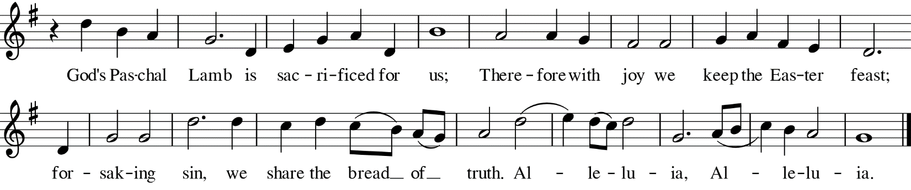

Celebrant The Gifts of God for the People of God.
Distribution of Communion
All are invited to come forward to the altar rail; you may stand or kneel. You may participate in Communion by receiving Bread and Wine, or by receiving only the Bread. You may either take a small sip from the common cup or intinct by carefully dipping the bread into the cup to receive the Wine. Gluten-free wafers are available upon request. If you do not wish to take Communion, or in lieu of Communion, you may come to the altar rail for a blessing. Instead of receiving the Bread and Wine, cross your arms over your heart, and the Celebrant will pray for God’s blessing upon you.

Communion Hymns Come, risen Lord, and deign to be our guest H 306
I come with joy H 304
Commissioning Prayer for Lay Eucharistic Ministers
Celebrant We send you forth bearing these holy gifts that those to whom you go may join with us in the body and blood of Jesus Christ. We are one body, one bread, one cup. Amen.

Post-Communion Prayer BCP 366
Celebrant Let us pray.
All
Almighty and everliving God,
we thank you for feeding us with the spiritual food of the most precious Body and Blood
of your Son our Savior Jesus Christ;
and for assuring us in these holy mysteries
that we are living members of the Body of your Son, and heirs of your eternal kingdom.
And now, Father, send us out
to do the work you have given us to do,
to love and serve you
as faithful witnesses of Christ our Lord.
To him, to you, and to the Holy Spirit,
be honor and glory, now and for ever.
Amen.

The Blessing
Closing Hymn Come away to the skies H 213
Dismissal
Celebrant Alleluia, Alleluia. Let us go forth into the world, rejoicing in the power of the Spirit.
People Thanks be to God. Alleluia, Alleluia.
Postlude Postlude – ChARLES CAPPELEN Julie Park
The Altar Flowers are given to the glory of God by Ada Pewitt.
The Altar Candles are given to the glory of God by Ben and Mirna Maddox, in thanksgiving for Claire.
Prayers are Requested
For those who are sick, hurt, or facing medical issues, especially:

Ellie Chang
Steve Davis
Mary Anne Delaney
Katie Ellington
Madeline Ellington
Ryan Harrigan
Kirk Hoffman
Kathleen Hoyt
Max Jabbonsky
Julie Jenkyn
Avery K.
Edwin Koski
Charlie Maltby
Divesh Manohar
Gracie Martinez
Myron Mazernac
Belinda McGhee
Joan Moreau
Deanne Quarrie
Gail Snyder
Christina Steele
Liza Stein
Abbie Teutsch
Elizabeth Treviño
Theodore Treviño
Ken Woodin
Rochelle and Jon Winkle
Toots Zynsky
Matias Gil-Egui

The Episcopal Diocese of Texas Cycle of Prayer:
All Saints', Fort Worth
All Souls, Arlington
Faith, Wichita Falls
The Anglican Cycle of Prayer:
The Church of Bangladesh
For those Celebrating Birthdays this Week:
Chloe Carrera (Apr. 28)
Claire Jones (Apr. 29)
Matt Curtis (May 2)
James Wall (May 4)
For those Celebrating Anniversaries this Week:
Carolyn porter & David Stuart (Apr. 30)
For those who have died and their families:
Vanessa Burkhead
For those facing difficult circumstances:
Ryen Herrera Dallas T
Gary Barnard Jesse & Christian Davis
Marguerite Barnard Laura Mazernac
Constance Koski Alex Jostad
Jean Shonkwile Debbie French
The Hernandez, Scott, & Fraga Families

Names added to the list this week are in boldface.
Names can be added to the list by using the prayer request
cards in the pew or by contacting the church office.

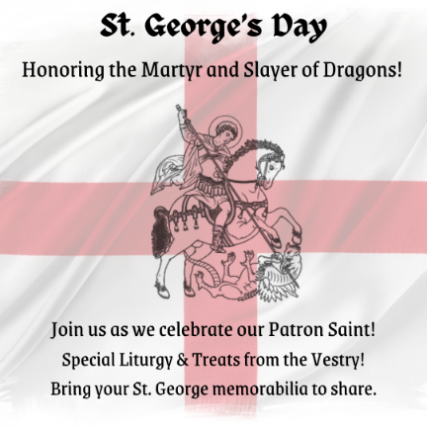
The Sunday Banner – April 28, 2024
- St. George’s Day – Join us TODAY in celebration of our patron Saint, St. George on! During the service we will have special liturgical variations in honor of St. George’s and join during coffee hour for special treats provided by the Vestry. Please bring any St. George knowledge, art, or memorabilia you may have to share with us all!
- Wednesday Weavings – St. George’s Wednesday Weavings adult discussion group gathers this week on May 1, from 6:30 to 8 p.m. at the home of Jan Phillips. We start the evening with a shared salad bar meal, then discuss a reading from our book, A Journey with Luke, and conclude with the liturgy of Compline. Please contact Frances Rickard at fajrickard@gmail.com for a copy of the reading or more information. Hope to see you there!
- St. George’s Court Birthday party - St. George’s Court is our church’s affordable housing program for the elderly and persons with disabilities. Every first Saturday, from 11 am to 1:30 pm, we descend upon the Court’s community room to enjoy lunch and cake, socialize, get to know residents, and play bingo with small prizes offered for winners. It’s a ton of fun for the whole family and an awesome way to serve as the hands and feet of Jesus Christ for these vulnerable residents, some have even been moved to attend Church on Sunday’s! Check out volunteer opportunities and sign up for any First Saturday through June at this link: https://signup.com/go/AqMnZty
- Women’s Book Group - will meet Saturday, May 11, from 3-5 pm at the home of Bouquet Boulter. This month’s book is The Sentence by Louise Erdrich. All women of St. George’s are welcome at this event, even if you haven’t finished the book. Call or text Sarah Campbell at 512.569.3081 or Alice Nelson at 512.924.1143 for further details or more information.
- New Choir Chairs – In light of the recent delivery of choir chairs you have a unique opportunity to own a genuine, certified choir pew! There are four lovingly used pews in the choir area that need a new home. If you would like one of those homes to be yours, please let John Rickard know as soon as possible and he’ll hold it for you until you can pick it up (though not indefinitely and hopefully this week). And if you need transportation, no problem! John can help with that, too.
- Photo Consent - Please sign the photo consent form provided to you by ushers or on the narthex table. You have the option of giving permission or not giving permission. We ask you to sign one for each member of your family, regardless of your decision. Questions, ask Sandra Villalaz, seniorwarden@saintgeorgesaustin.org
- “St. George’s 101” – A four-week Sunday morning Christian formation class introducing St. George’s to folks who are new and/or curious about life in our parish.
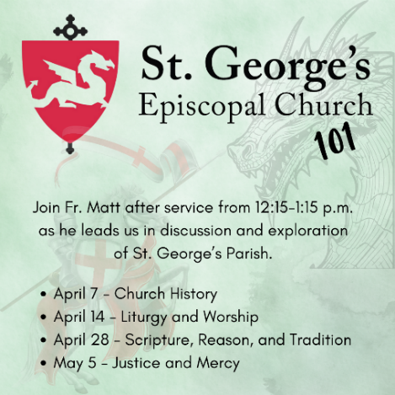
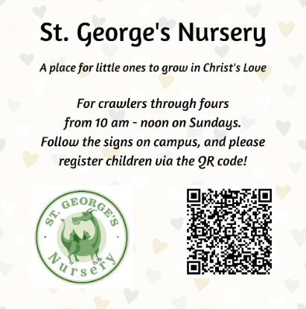

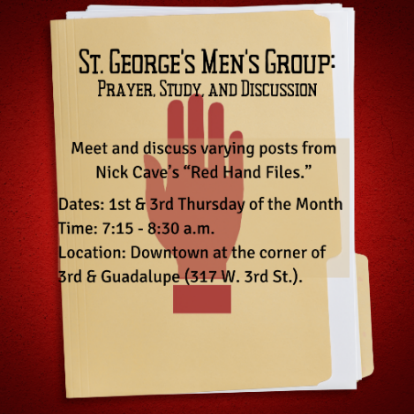
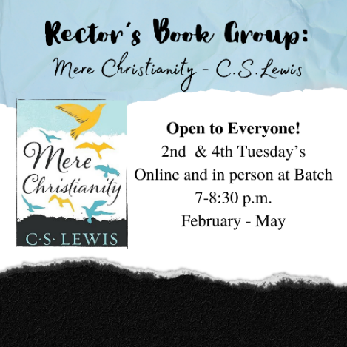

Next Sunday at St. George’s
Sunday, May 5
10:30 am Holy Eucharist Rite II
11:45 am Coffee Hour in Kleberg Hall
12:15 pm St. George’s 101 in the Wright House

The Week Ahead
Monday, April 29
6:30-7:45 pm Overeaters Anonymous (Kleberg Hall)
Wednesday, May 1
6:30-8:30 pm Alcoholics Anonymous (Kleberg Hall)
6:30-8:00 pm Wednesday Weavings
Thursday, May 2
7:15-8:30 am Men’s Group (Downtown)
7:15-9:15 pm Alcoholics Anonymous (Kleberg Hall)
Saturday, May 4
9:00-10:15 am Overeaters Anonymous (Kleberg Hall)
9:30-11 am Choir Practice

THOSE WHO SERVE TODAY
Vestry Person of the Day – Ramon Trevino
Altar Guild – Alice Nelson & Kimberly Thornton
Ushers – Alice Nelson & Sergio Garrido
Reader/Intercessor – Stephanie Andrews
Lay Eucharistic Minister – Patsy Chandler
Flower Guild – Alice Nelson
Nursery Volunteer – Tommie Ford

St. George’s Episcopal Church
4301 North IH 35 • Austin, TX 78722
Office Phone: 512.454.2523
Website: www.sgchurch.org
Email: admin@saintgeorgesaustin.org
Church Business Hours:
Mon.: 11-5, Tue.: 9-2, Wed.-Thu.: 11-6
Rector: The Rev. Dr. Matthew Boulter
737.600.2579 (cell)
Matt@saintgeorgesaustin.org

Permission to reprint, podcast, and/or stream the music in this service obtained from ONE LICENSE with license #A-719358. All rights reserved.

